Image | 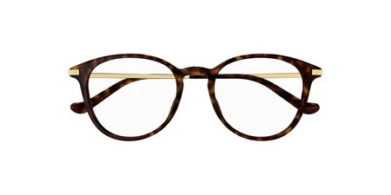
Brand | GUCCI
Model Name | GG 1466OA
Price | RS 1200
PRODUCT DETAILS

